
Year 9

Project 1

Area and Volume

Total Mark:________/24

Name: ______________________ Class: ______ Due Date : End of Week 6

Introduction: Garden Design
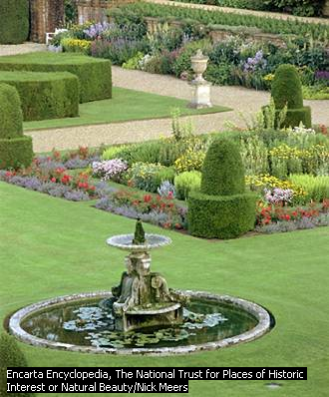
Garden Design is the creative use of space in the garden incorporating the landscape as well as the plants themselves. Boundaries, paving, and even furniture, water, and lighting are all elements of garden design. Garden designs are restricted by the size and shape, soil type, position, and climate. Plants and structures must be chosen to work effectively within these limitations and to balance visually with the exterior of the house.

Assignment Tasks:
Imagine you and your family have just moved into a brand new house in Karnup. The inside of the house has been decorated by a professional interior designer but the back yard is completely clear. Your challenge is to design a dream garden for your family. The backyard is 500m² and is surrounded by a dull grey fence.
Your design needs to include a turf lawn, plants, garden furniture, a pool/fish pond, paved/decked area and a garden shed. You should also remember to paint the fence and include an art work.

Grading will be based on the rubric for each of the requirements in the check list. You are to reflect on your work before submitting and grade yourself using the rubric. All work submitted must be in the form of an interactive notebook except through prior arrangement with your teacher.

Check list
Scale drawing; a detailed bird’s eye view of your garden design drawn on graph paper
- with a scale of 1cm = 1m and includes scale features of
- Garden beds
- Paved/decked area
- Turfed area
- Furniture
- Garden shed
- Pool fishpond
- Actual measurements on diagram of main features

Calculations (area and Volume); each clearly labelled
- Area of turf
- Area of paving /decking
- Volume of pool/ fish pond
- Perimeter and area of fence to be painted

Budget; use a table or spreadsheet to show the quantity and cost of each item ( you may add to the list)
- Rolls of turf
- Mulch for garden beds
- Pavers or decking
- 2 coats of paint
- Furniture
- Plants
- Pool/pond

Research and Costing calculations; clearly labelled and referenced.
- Research- catalogues/ internet/newspapers etc… to find cost (referenced)
- Individual calculations for each budgeted item. Labelled clearly

Art work
- Art piece complete
- Demonstrates use of geometric design
- Demonstrates use of symmetry
- Uses tessellations

Backyard Blitz Marking Rubric

Use this rubric to guide the depth of your work. Rate your own progress.

 | 1 | 2 | 3 | 4
Complexity of design and calculations | Rectangles only | Rectangles and triangles | Rectangles, triangles and circles | Composite shapes
Scale diagram | Diagram simple of external perimeter | Includes 2 features | Includes 4 features | Includes all listed features
Calculations | Some calculations with some mistakes | All calculations using formulas with some mistakes | All calculations using formulas. Maximum of two minor mistakes. | All calculations correct with units and assumptions made clear
Research /costings | 3 items costed no evidence of research | 3 items costed with some evidence of research | 4 items costed including turf calculations accurately with research | Detailed costings  With accurate calculations based on referenced research
Budget | List of 3 items with cost | 3 items, item cost per unit, quantity and total | All listed items, quantity, cost per unit and totals based on research and calculations. | All items + extras presented in a completed table based clearly on research and calculations
Art piece | Neat but Very simple and no evidence of geometrical design | Neat, simple showing either symmetry or tessellations | Neat, complex with rotational symmetry and tessellation aspects | Neat, complex with rotational symmetry and tessellation aspects. A written description of the types of the geometrical design

